New Traffic Lanes on Mainland

As part of the Pierce County request to remove ferry traffic from Herron Road, HMC and Pierce County have agreed to the following plan. There are now three waiting lanes for vehicles to be transported to the island and one exit lane off of the ferry.

While waiting for the ferry to go to the island please follow instructions below:

1. Fill Lane 1 first. Pull up to the white bar at the front of the lane. All cars should be parked bumper to bumper. The last car in the Lane 1 should not extend beyond the white bar at the end of the lane. If cars are parked bumper to bumper six cars should be in Lane 1.
2. Fill Lane 2 next. Pull up to the white bar at the front of the lane. All cars should be parked bumper to bumper. The last car in the Lane 2 should not extend beyond the white bar at the end of the lane. If cars are parked bumper to bumper six cars should be in Lane 2.
3. Fill Lane 3 next. This lane is the gravel on the north side of Lane 1. Pull up to the telephone pole at the front of the lane leaving enough room to pull out in front of Lane 1. All cars should be parked bumper to bumper. The last car in the Lane 3 should end at the street sign with the arrow pointing left and right. If cars are parked bumper to bumper nine cars should be in Lane 3.
4. Leave the exit lane empty so traffic can get off the ferry.

This new layout will reduce some parking in the HMC parking lot. This was part of the compromise reached with Pierce County to help remove parked traffic off Herron Road while waiting for the ferry. As time moves forward HMC may have to make some changes to this configuration.

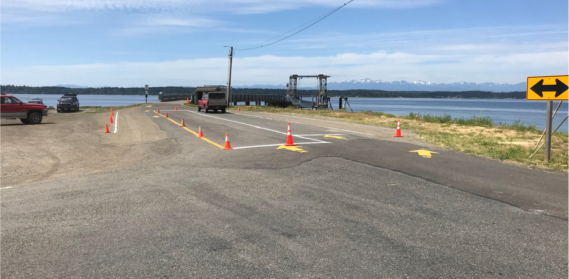

Exit Lane

Lane 2

Lane 1

Lane 3